2020 Bikeability Awards Programme – NOMINATION FORM
Please carefully read the Guidance Notes (click here) for the Bikeability Awards before submitting and completing this nomination. (also available on https://bikeabilitytrust.org/bikeability-awards/ )
Please send your completed form (and any attachments) by email attachment to contactus@bikeability.org.uk before noon on Friday February 28th 2020.
TO NOTE: Only one nomination can be submitted per form.
- Your Details
First name: Linus | Surname: Welsh
Organisation/Group (if applicable): AFC Fylde Community Foundation
Address and postcode: Linus Welsh, Fylde Sports and Education Centre, Mill Farm Sports Village, Coronation Way, PR4 3JZ
Email address: linus.welsh@afcfylde.co.uk
Telephone: 01772 598852 | Mobile: 07394 566857
If not a self-nomination, briefly describe your relationship with the nominee (e.g. work colleague, employer, pupil, other): Colleague, watched the programme grow from a business perspective and shadowed the activity many times in the past.

- Nominee’s Details (main contact)
If submitting a nomination for Trainee of the Year, please provide their name and/or their parent/teacher/carer contact details if more appropriate.
First name: Paul | Surname: Armitage
Organisation/Group (if applicable): AFC Fylde Community Foundation
Address and postcode: Linus Welsh, Fylde Sports and Education Centre, Mill Farm Sports Village, Coronation Way, PR4 3JZ
Email address: paul.armitage@afcfylde.co.uk
Telephone: 01772 598852 | Mobile: N.A
Name of award for which he/she/they/the organisation is being nominated (please highlight/underline/select one):
- Instructor of the Year
- Bikeability Provider of the Year
- Local Authority/SGO Host School Partner of the Year (outsourced delivery)
- School Employee or Governor of the Year
- Trainee Rider of the Year (Pete Rollings award)
- Most Proactive Primary School

- Please describe below the reason(s) why the nominee deserves this award (maximum 300 words)
NB – you should refer to the award criteria when completing this section and try to explain how the nominee has meet some/all of the different qualities described.
The Foundation are renown throughout the Fylde Coast for delivering an outstanding, professional and safe Bikeability course throughout Primary and Secondary School settings.

Single handedly co-ordinating a fantastic Bikeability offer throughout the Fylde, Paul leads the entire process from originally booking in the schools, to preliminary assemblies with the school to let them know what they have in store, route and safety planning and leading the delivery.

Throughout the year Paul runs this operation with around 31 local Primary Schools throughout throughout Fylde and ensures all children get maximum attention to help them develop with their cycling and develop with passing the course.
In my eyes, Paul is the ideal candidate for Instructor of the Year, the passion shown reflects on his fantastic pass rate and he has been known to visit school in extra-curricular hours to ensure children are able to pass the course if they fall behind.

Paul is genuinely passionate about Bikeability and takes a great amount of pride in ensuring children of the Fylde Coast take part in the best Bikeability experience possible. I couldn’t think of a better candidate for the award.
2. Please list below any accompanying high-quality evidence to support your nomination (eg. materials, photographs, video clips, testimonials) Up to a maximum of 3 items and provide a title for each item(s) in the section(s) below – do NOT include any further written information on the form. Ensure all the attachments listed above accompany your nomination form, and are clearly labelled so it is clear which nominee they apply to. Maximum number of words for each item of accompanying evidence is 300 – submissions that are longer than this will not be considered.
- Paul Armitage delivering initial assemblies with a local school and running through bike-safety checks to ensure children are prepared and ready for their upcoming Bikeability experience. 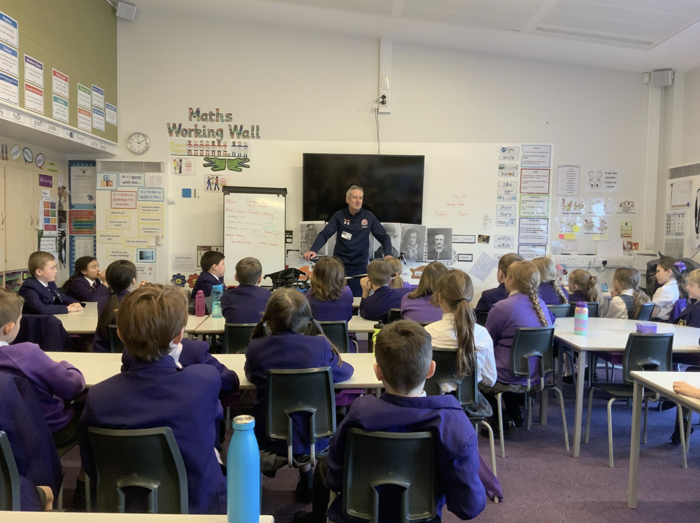
3. Please briefly describe any other experience or insights you feel are relevant to your nomination. (maximum 300 words)
Over the past 2 months, we worked with a school who had a number of students that were struggling with completing their Level 2 achievement in Bikeability. Paul understood the children were passionate about cycling, yet just lacked the experience to complete the course, rather than just moving on and the children being left without the qualification and disheartened about cycling, Paul set up after school sessions with the school to ensure all children that wanted extra expereince were able to take part and able to achieve their qualification.

We believe that with this extra dedication shown, it’s allowing the children to build confidence with their cycling and continue to develop into road safe cyclists. Without the additional efforts from Paul, these children would be left disheartened and un-motivated to cycle.

Qualities like these are why we believe Paul is an ideal candidate for Instructor of the Year.
- I confirm that the information I have provided is accurate, I have permission (as appropriate) from nominee’s parent(s) to submit this form/from those people in any materials submitted to share their images/comments. And I have read and agree to the Terms & Conditions.
Name: Linus Welsh
Signature:
Date: 28/02/2020
To be signed by an independent individual / organisation representative:
I can confirm that I believe this to be an accurate submission and add my support to the application
Name: Matt Agnew
Signature:
Date: 28/02/2020
Organisation (if applicable): AFC Fylde Community Foundation

