

Bikeability Plus Cambridgeshire

# Summer Term 2019

# 

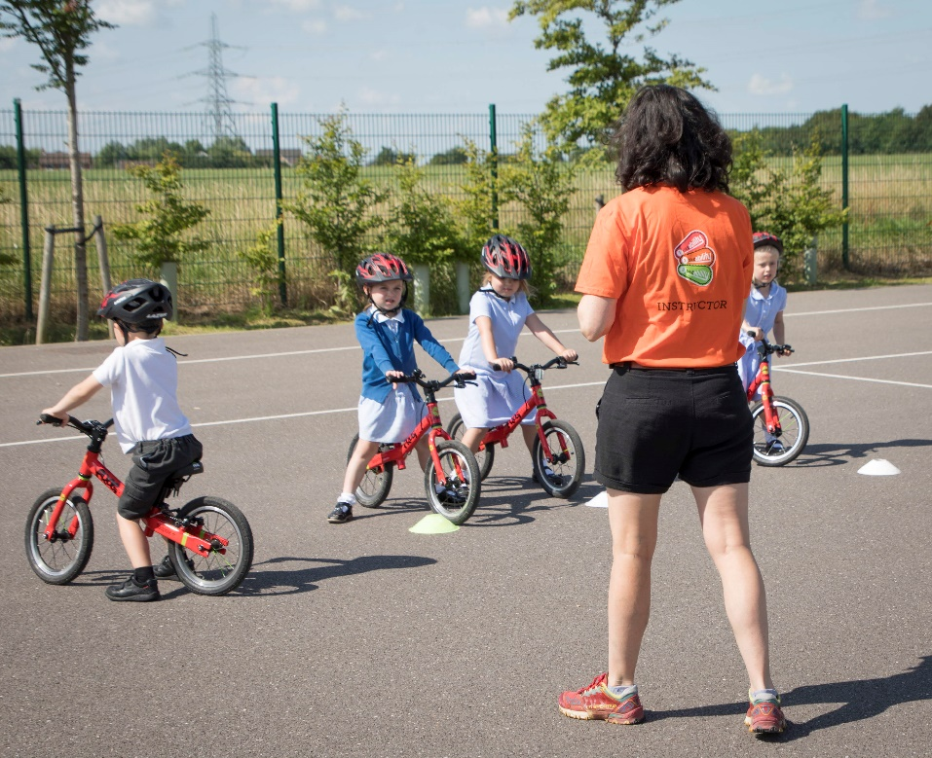

# Contents

|  |  |
| --- | --- |
| Title | Page |
| Project Summary and Key Impacts | 2 |
| Why was the Project Successful? | 3 |
| Results | 5 |
| Feedback | 6 |
| Conclusions | 7 |

Project Summary and Key Impacts

The Bikeability Plus project is aimed at pupils, parents and teachers and is used to encourage change in their method of transportation to and from school. The project takes place over 5 weeks within 4 schools and is made up of different challenges and activities that help teach and excite participants about cycling.

The activities that took place over the 5 weeks were the following:

* Try-Out Show – Run by Outspoken Cycles which involved activities and bikes to use such as the ‘Pedal Powered Disco’ and ‘Tandem Bikes’
* Bikeability Balance – Training for pupils in Reception using bikes without pedals to help encourage balance
* Bikeability Fix – Training for pupils in Year 6 on their own bikes to learn how to maintain and fix a bike
* Bikeability Learn to Ride – Training for pupils who are non-riders

The schools that took part in this training are: Stretham, Isleham, The Shade and Thomas Eaton which are all based around the Cambridgeshire area. Within each school there were activities for all the year groups to ensure everyone was included and had the opportunity to learn new skills and get motivated about cycling.

# Key Impacts

* The number of children cycling to school rose from 158 to 337 which is an increase of 113%
* 83 children were introduced to cycling through the Balance Bike training
* 47 children learnt how to ride for the first time
* 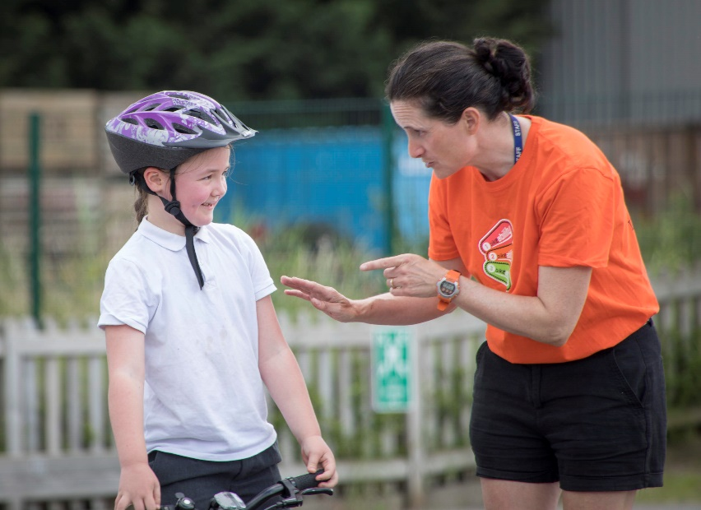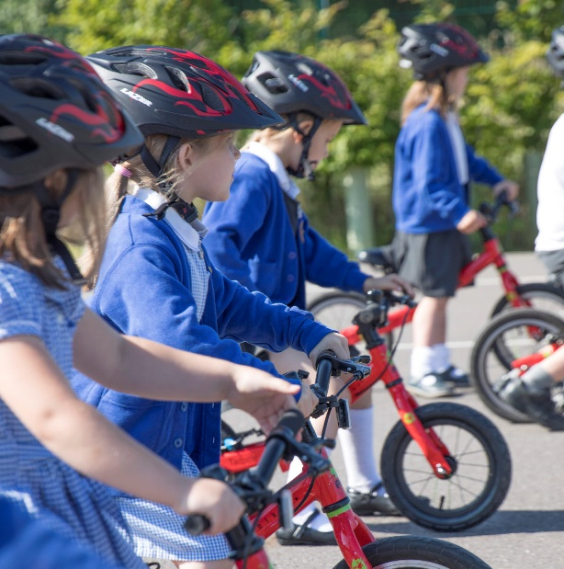32 children became junior bike mechanics through the bike maintenance training

Why was the project successful?

The main success of the project was due to the incredible efforts of the instructors and staff involved in the training at the schools. The ensured that everyone was motivated and safe as possible, and made the whole experience extremely enjoyable for everyone. Many of the instructors had taken part in Bikeability Plus project prior to this one which benefitted the project as they were able to use their experience to explain how the project worked clearly to teachers, parents and pupils and prevent issues before they occurred.

# Project planning

The first stage was to select the schools that would take part in the project. The schools had to be relatively close to one another and had to have a maximum of ~200 pupils in total in the school. The schools that were selected for this project were:

* Stretham
* Isleham
* The Shade
* Thomas Eaton

Each of these schools were individually visited by our Instructor Trainer and the instructor who would be leading the training. This allowed the schools to meet them both and run through what would take place during the project.

# Enthusing and rewarding

The project started with a Try Out Show run by Outspoken Cycle which gave the pupils, parents and teachers a chance to experience using different types of bikes such as Tandem and Pedal Powered Disco. This helped create excitement for the project for the following weeks.

As well as this during the second and final week of the project the class who had the largest number of new cyclists or ‘most improved’ would win a prize. The first round of prizes were bike lights and the second round were Bikeability Plus water bottles. This helped create a friendly competition between the different year groups and encouraged more children to cycle to school.

# Engaging the teachers and parents

To ensure that everyone got involved in the project we ran an afterschool event, the Try Out Show, which allowed parents and teachers to take part in some cycling activities along with the pupils. This got the parents motivated about cycling and gave the teachers an opportunity to join in. Bringing the teachers into the training gave them had two major benefits. Firstly, it helped give the student a familiar role model to encourage them to cycle. It also was an opportunity to see what the students would be doing during the project and let them get to know the staff who would be working during the project.

# Cycling activities

There were a range of different cycling activities organised to take place to educate and enthuse the participants.

* 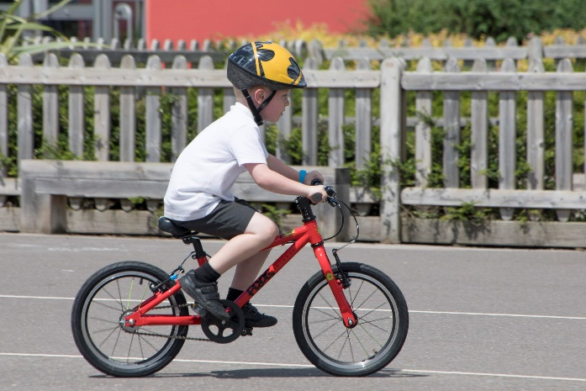**Try Out Show** – This event included the whole school and parents. It was made up of activities such as the ‘Pedal Powered Disco’. This is a stationary bike hooked up to a blender. The delivery of the smoothie was powered by the participant cycling. This event also gave everyone a chance to ride bikes such as the ‘tandem bike’ and ‘half bike’.
* **Bikeability Balance** – The reception class were involved in weekly balance bike training sessions which involved games which helped strengthen core balance skills. This training is used as an introduction to cycling and helps children learn to balance so they are more confident when moving on to A pedal bike.
* **Bikeability Learn to Ride** – This training involved children across several different year groups and helped them ride a bike without stabilisers or falling off. The training was an hour long and a total of 57 children took part. By the end of the project 47 went away riding a bike independently.
* 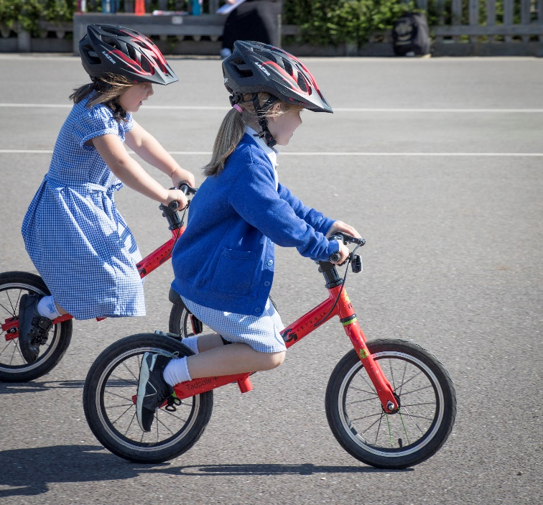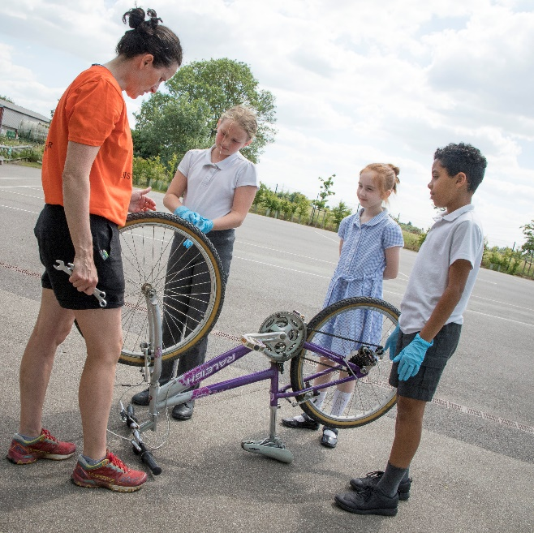**Bikeability Fix** – This activity gave pupil an opportunity to learn how to fix their own bikes. This was done over two 45-minute sessions and involved them learning how to repair a puncture, remove wheels and make minor adjustments to their bikes.

Results

The results from this project are all positive and have reflected our aim. This can be seen through an increase in cyclists weekly across all 4 of the schools. Below is a table which has all the data collected from the schools provided over the 5 weeks in which the project took place. This data was collected from each class by the school.

Each class from the different schools were all seen to improve on the number cycling into school which can be seen represented below. This was a brilliant result as we did have an issue with heavy rain and general bad weather for the first two weeks.

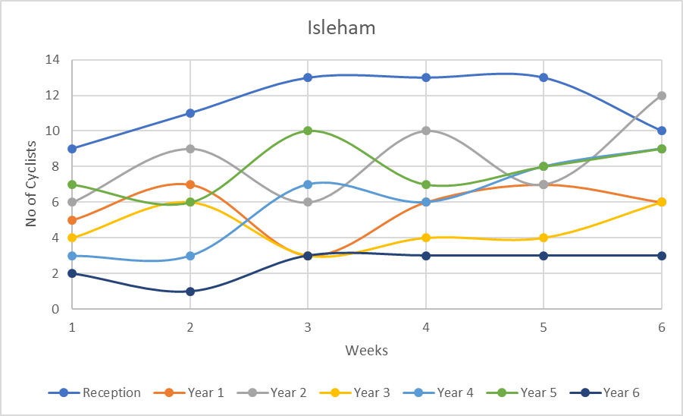

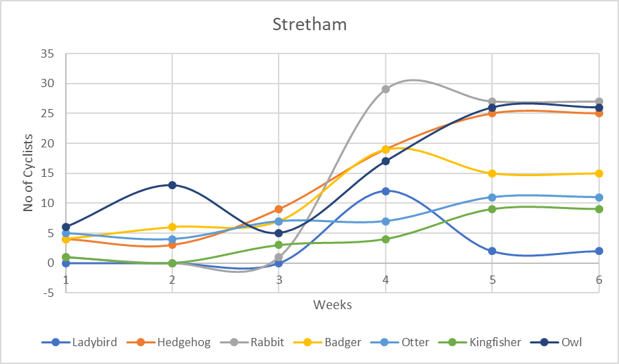

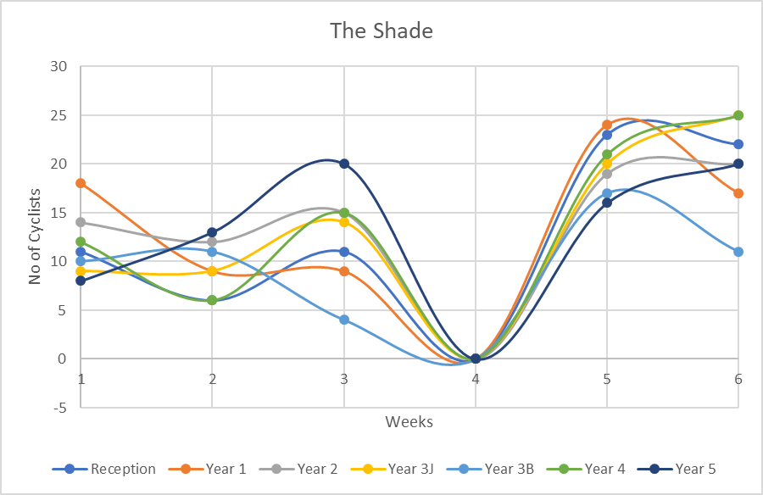

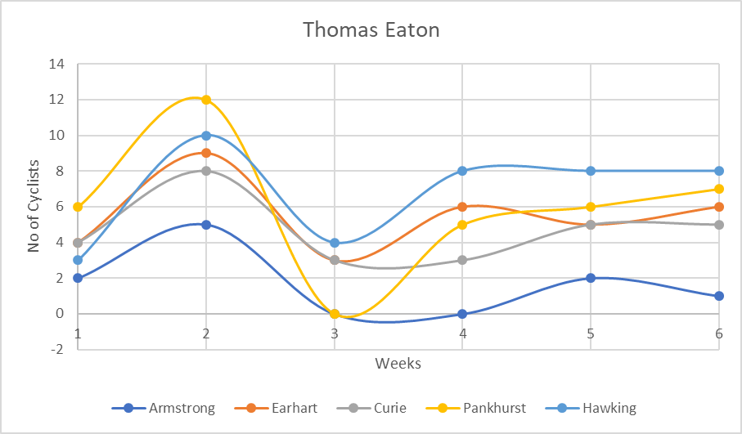

Feedback

**Pupil Feedback**

*“I really enjoyed trying out the different types of bikes. My favourite was the half bike because it felt really different. At first it was hard to steer but I got used to it. I helped the little ones at lunch when their chain fell off. I have my own mountain bike and love going on trails with my dad. I hope that bike riding will remain my hobby. Riding my bike makes me happy and keeps me fit.”*

*“I rode for the first time ever! It was nice to see if I could ride a bike. It has given me a new confidence to try and ride. My arms and legs get tired very quickly, so this was a big achievement. Because I can’t see very well, I have a cane, going on the tandem was brilliant as someone driving could see!”*

**Parent Feedback**

*“We agree that biking is good for our children’s mental health and prefer them being outside on a bike rather than watching a screen. Our children enjoyed the session and recognise their individual progress during them.”*

**Teachers Feedback**

*“The children really enjoyed this opportunity to be outside on their bikes. The younger children loved the balance bikes and have really improved their balance and coordination skills. The children enjoyed the games that Anna used in order to practise their skills. The children who ‘learned to ride’ are thrilled in acquiring this new skill. It was absolutely wonderful to see the joy on their faces when they mastered the skill of rising independently. Anna’s use of simple phrases which the children chanted really supported their understanding. The bike maintenance groups all felt confident in mending a puncture and were very clear that they will all check their ABC’s before going out on their bike in the future.”*

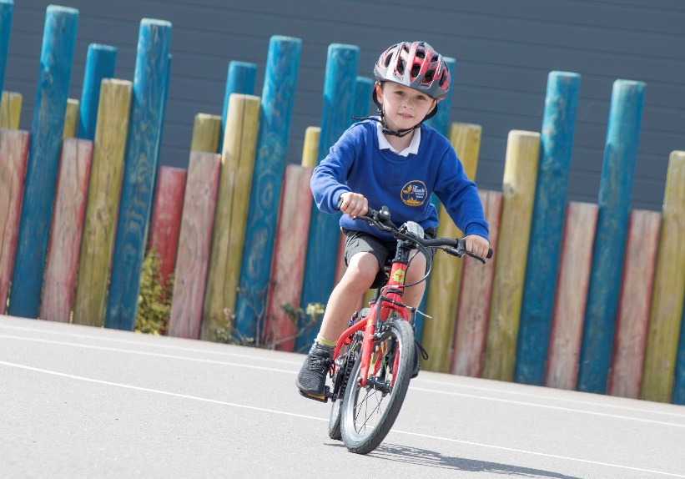

Conclusion

In conclusion the project was a huge success! As demonstrated within the results the project helped encourage change of transportation to school by participants which throughout the project was seen to improve weekly. The projects aim was achieved and will help ensure that future cycling by the participants will be safe.

From the results from this year, and prior years, in which the Bikeability Plus project has run it is clear that it achieves its aims and is very beneficial for school and pupils alike. This can be seen through the data collected and from the feedback received by pupils, parents and teachers.

A challenge during this project was the collecting of data. This was because it was quite hard for some of the schools and sometimes misunderstood even after our instructors went to the school before the project and explained. The challenge for the schools not understanding what data to send in prevented us from collecting data on time and therefore meant a slower delivery of prizes for the classes during the competition.

One improvement that can be made for the next project would be to use a different method of collecting the data as some schools were confused by this which lead to us missing data for a week at the Shade. This could be done using an online tool or by sending a package or file which includes all the documents that are required for the project at one time so the schools can see what they will need to do and when in advance.

Thanks go to Cambridgeshire County Council, Anna Hay and Outspoken Cycles for helping throughout this project and providing us with the support we need to achieve these fantastic results!