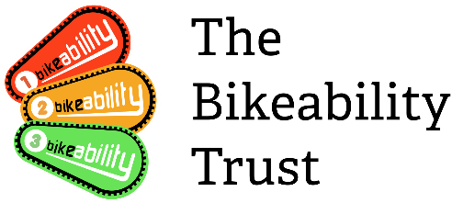

The table below maps out the key papers on child cycling and cycle training. Papers highlighted in bold are the most recent and robust primary studies. Papers in light grey text are by now quite old and were undertaken before the launch of Bikeability.
 | Current (2014/15) | Medium (2011 to 2013) | Older (pre-2011)
Safety impacts | NFER hazard perception research (2015)  Narrative review of child cycling (2015) | Childwise brand awareness (2011)  SDG brand awareness (2012)  Ducheyne cycling skills (2013) | RoSPA effectiveness of training (2001)  TRL effectiveness of training (1996)  Ipsos MORI parent survey (2010)  Mott MacDonald Merseyside (2009)  Colwell and Culverwell Bromley (2002)
Frequency of cycling | NFER hazard perception research (2015)  TABS school survey (2014)  Ipsos MORI parent survey (2015) | SDG school census data Herts (2012)  SDG Tower Hamlets (2011) | Atkins TTSI evaluation (2010)  Ipsos MORI parent survey (2010)  Mott MacDonald Merseyside (2009)
Delivery models |  | Transport Scotland parental (2011)  Ducheyne cycling skills (2013) | RoSPA effectiveness of training (2001)  SDG Lambeth (2008)  Macarthur Toronto scheme (1998)
Barriers to child cycling:  - Parental perception of road danger  - Parent to parent peer pressure  - Mode decision makers  - Distance  - Routine  - Car culture  - Socio-demographics  - Child attitudes (boys/girls)  - Terrain, weather, lighting  - Independent mobility  - Cycle ownership  - Free bus travel |  | Benson and Scriven mode choice (2012)  Ducheyne distance (2012)  Trapp routine (2011)  Loitz car culture (2013)  Mott MacDonald Merseyside (2012)  Edwards bus impacts (2013) | Lorenc Parent peer pressure (2008)  Ligtermoet distance to school (2010)  Atkins TTSI evaluation (2010)  TfL sociodemographics (2008)  TfL cycle ownership (2008)

