2020 Bikeability Awards – Nomination for Most Proactive Primary School
Shinfield St. Mary’s Junior School, Wokingham - Evidence to support nomination

Evidence 2 – Testimonial from Terry Holmes, NSIQ
I would like to comment on how much standards of cycling at Shinfield St. Mary's improved. I have taught Bikeability levels 1 and 2 at the school over a number of years and have seen a significant improvement in the cycling skills of those taking part in the last two years or so. Skills such as overall control, riding one handed, and controlling the bike whilst looking around had definitely improved.
I visited and taught there in September 2018 and noticed a marked difference in the standards of cycling which translated into confident riding on quieter roads. Students showed a good understanding of the core elements of riding safely and communicating well with other road users. Numbers of participants had also risen in this year with, I believe, 67 out of 88 children doing the level 1 & 2 course. An amazing take-up figure!
Returning to the school in June 2019, we were able offer Level 3 courses to 39 year 6 students, a mark of the competency and confidence of these children. We found that they responded well to the challenges of busier roads and seemed to get a lot out of the course. This was a fantastic achievement for children in this year group.
Long may this incredibly important work continue.
Terry Holmes NSI(Q)

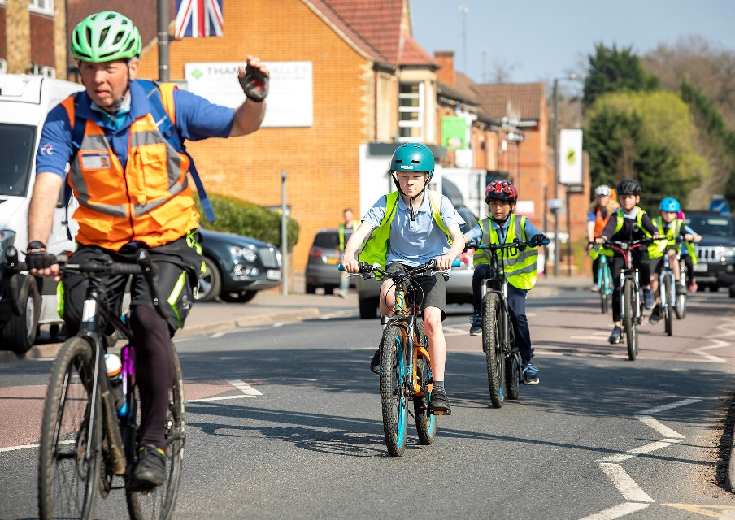
Terry leading a Bikeability Level 3 course

