2020 Bikeability Awards – Nomination for Local Authority of the Year
Wokingham Borough Council - Evidence 1
CYCLING ACTIVITIES IN WOKINGHAM

Bikeability Level 1, Level 2 and Level 3 courses
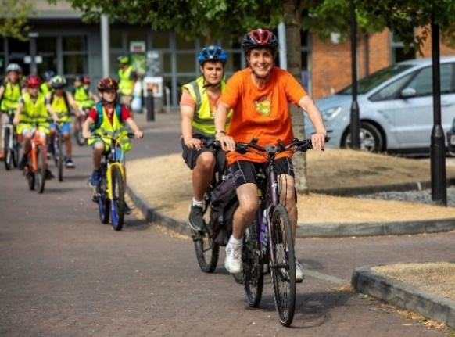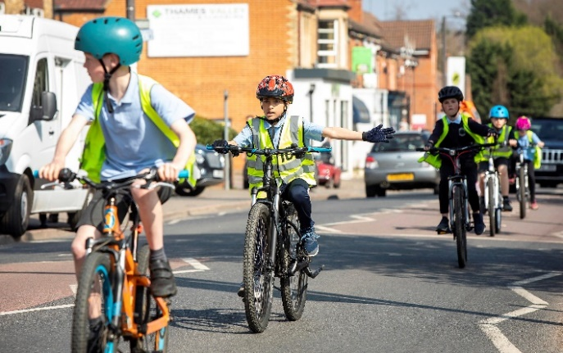

Bikeability Balance and Bikeability Learn to Ride
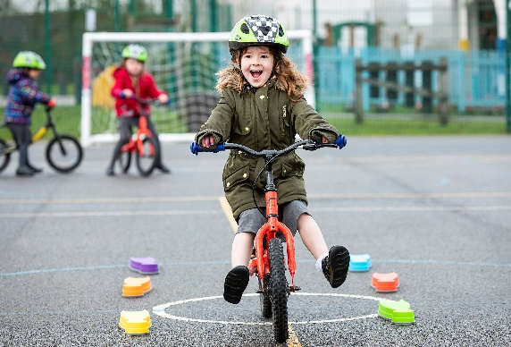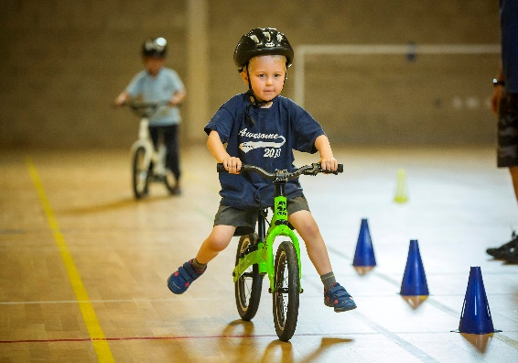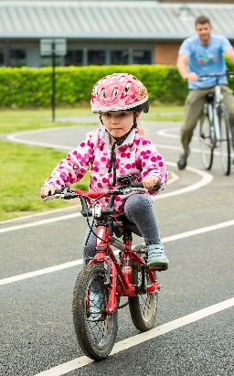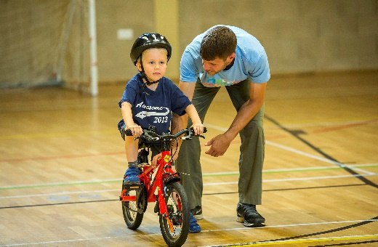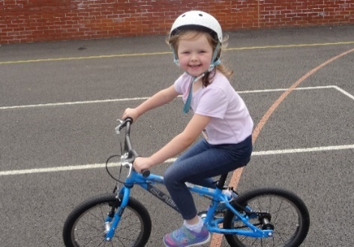
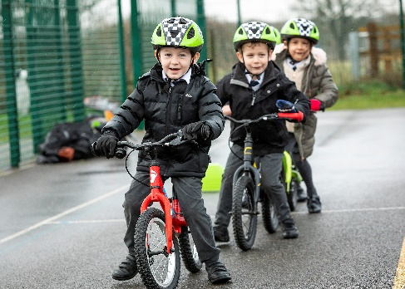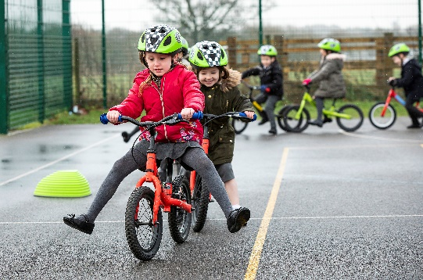

Bikeability Promotion, Bikeability Fix , Bikeability Ride and Bikeability Transition
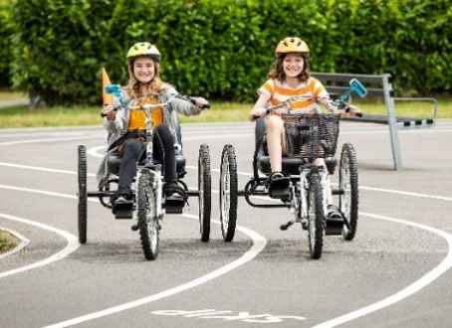
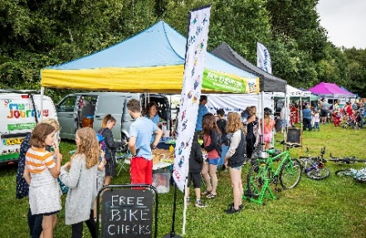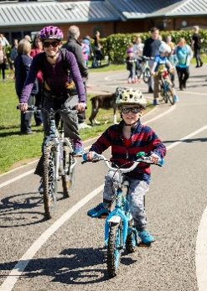
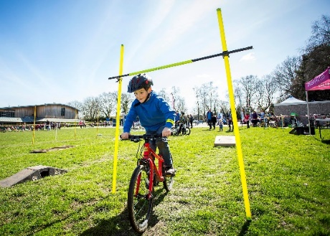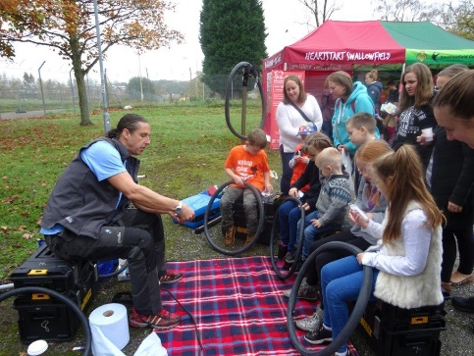

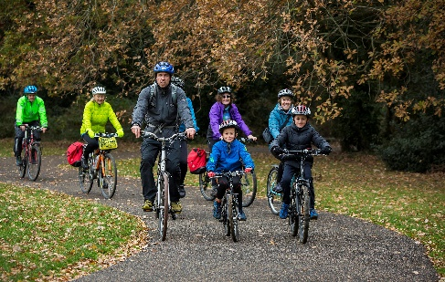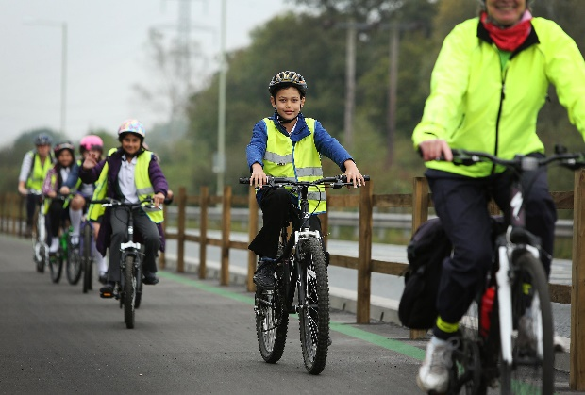
Links to FaceBook slideshows of Bikeability activities:
https://www.facebook.com/MJWokingham/videos/2194152907325718/
https://www.facebook.com/MJWokingham/videos/329859791109171/

Bikes, Big Trucks & You Project
Bikes, Big Trucks & You is a partnership between Royal Mail and Berkshire local authorities, addressing the significant increase in risk to child cyclists as they transition into secondary education and independent travel; especially around HGVs. The project is delivered as a 2 hour session for Years 5 or 6, after the children have attended a Bikeability Level 1/Level 2 course.
The Royal Mail supply the truck and 3 staff, whilst the My Journey Wokingham team deliver a classroom session at the beginning of the day, then assist with the practical workshops or “Zones” based around the truck. Every child gets the opportunity to sit in the driver’s seat and look in the mirrors to see if their classmates are visible in various different zones.
Evaluation has shown that children who have attended this project have a much better understanding of driver blind spots and the issues of cycling near big trucks or other long vehicles and this prepares them well for Bikeability Level 3 training.
---------------------------------------------------------------
“I just wanted to email and say thank you for the Big Truck Day. The children thoroughly enjoyed it and staff felt it was incredibly beneficial to run especially for our children who have recently had their Bikeability course. Please pass our thanks onto all your staff – they were great with the children and very knowledgeable!”
Amy Woods, Year 6 teacher, Hawkedon Primary School

(Photos from Evendons Primary School, Wokingham.)





