2020 Bikeability Awards – Nomination for Local Authority of the Year
Wokingham Borough Council - Evidence 2
Inclusive Cycling in Wokingham
Cycle Experience were able to support Sadie Stoddard, a year 6 pupil at Winnersh Primary School in
Wokingham to achieve Bikeability Level 2.
Sadie and her family have been asked to become ambassadors for the Bikeability Trust, where they will help spread the importance of giving children access to Bikeability. Sadie’s story was published in December 2019’s Bikeability Trust newsletter as well as receiving local press coverage.
https://www.thettcgroup.com/news-and-resources/bikeability-training-sarah-and-sadie-stoddard/

The MyJourney Wokingham team ran Bikeability Learn to Ride and Bikeability Level 1 holiday courses specifically for children with high-functioning autism.
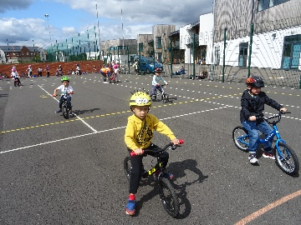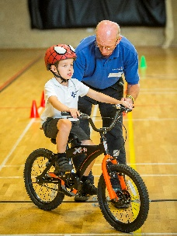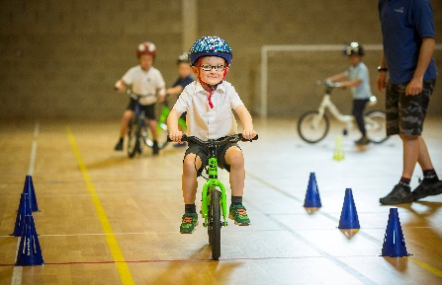
Woky Wheels for All
Weekly inclusive cycling sessions for adults with physical and learning disabilities are run at the Finchampstead bike hub. In Autumn 2019, all of the participants took part in Bikeability Level 1 training and a group of them are currently enjoying Bikeability Level 2 training.
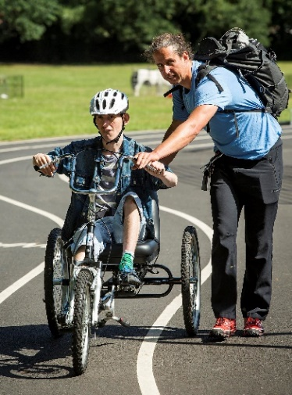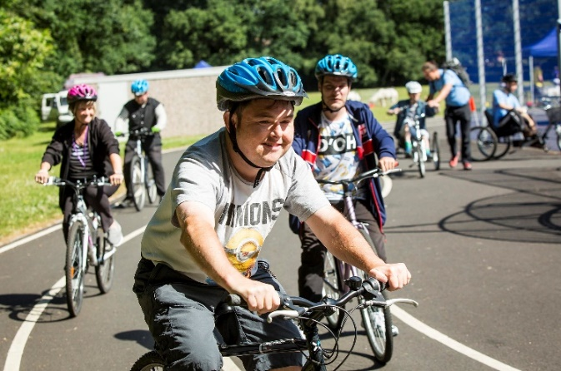
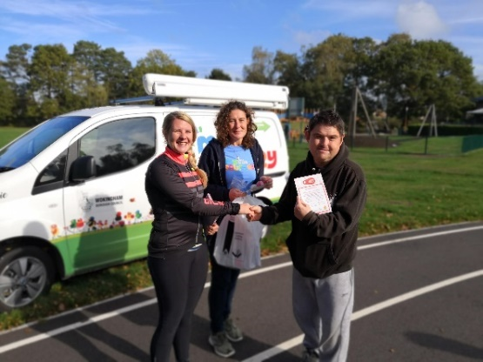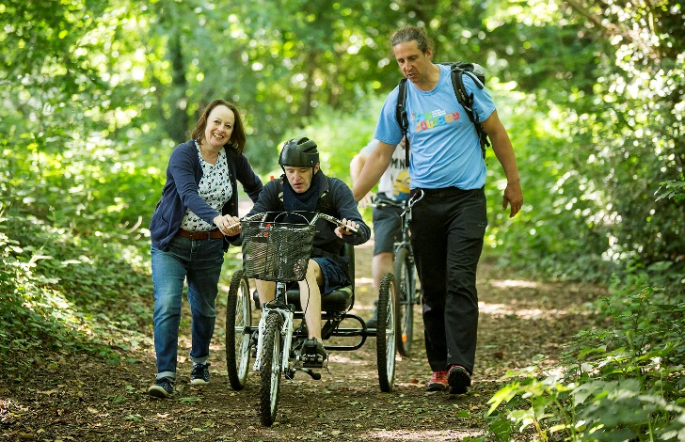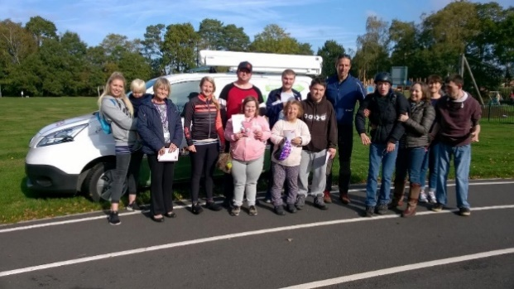

Some quotes from Woky Wheels 4 all participants:
Dean: “I've thoroughly enjoyed this session, I feel more confident using a two wheel bike. The staff who run the session are so helpful.”
Thomas: “As a member of the bike group, I’m feeling more confidence to get on my bike as a hobby. It is a great way to get fit.”
Nick: “I always look forward to cycling with Woky wheels 4 all and enjoy it so much. It has helped me with my mobility needs and given me the confidence to believe in my abilities and enjoy exercising with friends despite my pain and disability.”
Robyn and Holly (Robyn’s carer): “I enjoy Woky wheels for all, I love cycling around the woods and seeing the animals and nature. I enjoy the fresh air and the exercise.”

________________________________________________________________

